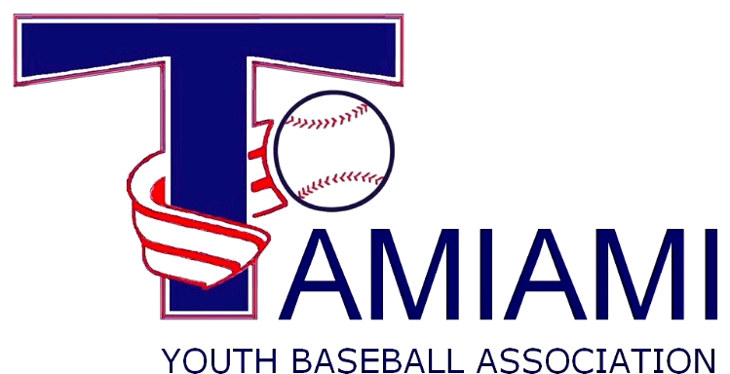
___________________________________________________________________________________

2018 ROSTER

The Fee for complete teams in Mustang, Bronco, Pony and Colt, with a maximum roster of 15-players is: $1,800. Teams must provide their own uniforms & equipment.

Team Name: Division: C. Pitch ( ) Pinto ( )
Manager: Mustang-A ( ) Mustang-B ( )
Coach: Bronco-A ( ) Bronco-B ( )
Coach: Pony-A ( ) Pony-B ( )
Colt ( )

Player Name: Date of Birth:
1.
2.
3.
4.
5.
6.
7.
8.
9.
10.
11.
12.
13.
14.

